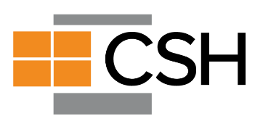

2022 Supportive Housing Institute

Institute Overview
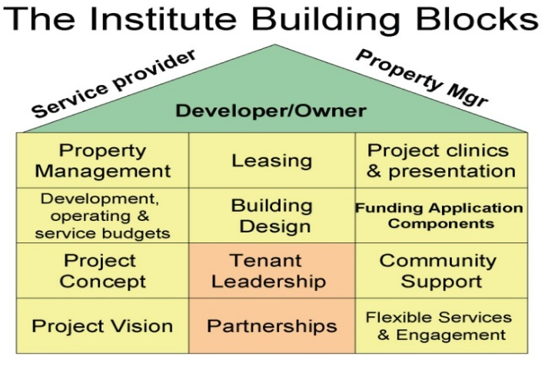
The 2021 Institute will address issues of homelessness with a focus on serving households with high needs in Arizona. The Institute will help supportive housing partners learn how to navigate the complex process of developing housing with supportive services to prevent and end homelessness and develop capacity to deliver high quality housing and services to our most vulnerable community members.
The 2021 Institute will provide targeted training and technical assistance for both new and experienced development teams. Teams will receive custom training plus individualized technical assistance and resources to assist in completing their project.

Institute Benefits
Upon completion, participants in the Institute will have:
- A detailed, individualized supportive housing plan that includes supportive service and delivery strategies that can be used to apply for funding from multiple sources;
- Improved skills to operate existing supportive housing and develop new projects serving people who experience multiple barriers to housing;
- A strong, effective development, property management and service team that leverages the strengths of each team member and has clearly defined roles and responsibilities;
- A powerful network of peers and experts to assist in project development and to trouble-shoot problems; and
- Post-Institute technical assistance from CSH.

Institute Deliverables
In the course of the Institute, teams will work to develop individual supportive housing project plans. The expected team deliverables include:
- Project concept, including site selection and minimum development design characteristics;
- Memorandum of Understanding among members of the supportive housing development team, outlining the roles and responsibilities of each partner;
- A team vision and mission statement;
- Community support plan;
- Detailed service delivery plan;
- Tenant Selection plan;
- Tenant Leadership plan;
- Management plan;
- Operating policies and protocols between services provider and property manager; and
- Preliminary project proposal and budgets.

Institute Calendar and Curriculum
Tentative Schedule for each Virtual Training Session:
Training Session: | 9:00am-12pm

January 2022 – May 2022 | TOPICS
 | Part 1: Introduction to Supportive Housing
Session 1 | Introduction to the Institute and Supportive Housing; Local & National Context- Understanding need
Session 2 | Quality Supportive Housing; Intro to Quality Endorsement
Session 3 | SH Roles & Partners; Project Concept (Network mapping); Building a network of support and community buy in.
 | Part 2: Tenant-Centered Design
Session 4 | Trauma Informed Design; Concept design (SH philosophy)
Session 5 | Service strategies and partnerships; Service design and delivery (Supportive services plan)
Session 6 | SH Budgets; Local sources of funding and pre-development endorsement; Service budgets (Staffing model tool)
Session 7 | Service budgets cont. With Operating budgets and sources.
 | Part 3: Capital Financing and Property Management
Session 8 | Finance: Capital Budgets (Asset Management) Development
Session 9 | Property Management and coordination
Session 10 | The first year – move ins, coordination (Coordinated entry, prioritization)
 | Part 4: Development Planning
Session 11 | Quality Improvement; Supporting Housing Retention and Engagement – Focus on Thriving
Session 12 | Fair Housing
Session 13 | Project prep and Quality Endorsement review/applications
Session 14 | Project Presentations

Eligibility and Selection

Eligible Teams
Teams are invited to bring up to five members to each Institute session. Eligible teams must include, at a minimum, a designated team leader, a developer partner, a supportive service provider partner, and a property management partner. Teams will also include an owner partner if they’re not represented in the three other partners. Teams are also encouraged to incorporate the feedback and experience of current or prospective supportive housing residents into their project. This could be either through direct participation in the team by a staff member of one of the partners who has lived experience or through focus groups or other already existing groups of tenants/community members.

Each team will have a designated team leader who may be the developer, service provider, property management or owner partner. Additional team members may include, but are not limited to, consultants and/or award administrators, local city development staff, local housing authority staff, or Continuum of Care representatives.

Developer, Property Manager and Supportive Service Provider entities may be listed on multiple proposals, however, a separate dedicated staff member of equivalent position within the organization must be listed as the lead for each separate proposal.

To be eligible for the Institute, all team members must be able to commit to attending ALL training sessions offered and commit to taking the project concept from idea to completion with the goal of having supportive housing units placed in service. It is critical to the success of each team that key senior management staff members consistently participate in all sessions. The Institute will consist of 14 training days over five months.

Eligible Supportive Housing Projects
100% Supportive Housing and Integrated Supportive Housing (mix of affordable and supportive housing) developments are eligible to apply for the 2021 Institute. For integrated developments, there must be a minimum of 25% of units for supportive housing.

For each development the following requirements will apply:
- Housing is permanent and affordable;
- Tenants hold leases and acceptance of services is not a condition of occupancy;
- Housing is based on the Housing First model which includes eviction prevention and harm reduction strategies;
- Comprehensive case management services are accessible by tenants where they live and, in a manner designed to maximize tenant stability and self-sufficiency;
- The supportive housing development must focus supportive units on homeless or at-risk households;
- The supportive housing development must design tenant screening in a manner that ensures tenants are not screened out for having too little or no income, active or a history of substance use, a criminal record (with exceptions for funding mandated restrictions), or a history of victimization (e.g. domestic violence, sexual assault or abuse); and
- The development considers reporting through the regional Homeless Management Information System (HMIS).

Proposals to develop emergency shelters, transitional housing, or shared housing such as group homes will NOT be considered.

Target Populations
The Supportive Housing Institute is being offered to address homelessness in Arizona, therefore the targeted population for Supportive Housing are individuals and/or families who are chronically homeless, have complex physical or mental health needs or are justice involved. We encourage teams to reach out to CSH, health care partners or your Continuum of Care to discuss populations most in need of housing in your community.

During the Institute process, CSH will work with each team to finalize their tenant selection plans and ensure alignment with eligibility for federal, state and local programs providing funding for capital. services and rental assistance.

Selection
In order for CSH to provide an appropriate level of technical assistance, the 2021 institute will be limited to up to 6 teams.

Consideration will be given to the following factors:
- Commitment to developing Supportive Housing Project and participating in the Institute;
- Capacity and experience of the team members, including financial stability;
- Quality of the response to the application questions; and
- Alignment with the mission and goals of the Institute.
Selection is a competitive process. Applicants must take care in responding to all requirements of the Application. Please provide detailed information in the application response and do not assume that reviewers will be familiar with your organizational capacity or project concept.

Application Instructions

Application Deadline: Monday, November 8, 2021 by 5 pm (AZ)

Submission: Please send the completed form to Margaret Adams at margaret.kilman@csh.org
An email confirmation will be provided as proof of receipt. If you do not receive a confirmation within 24 hours of submission, please contact margaret.kilman@csh.org. It is the applicant’s responsibility to confirm receipt of the application.
The Application Review Team will evaluate all proposals submitted and notify respondents of the selection decision by Monday, November 29, 2021. All applicants must block off Institute session dates so they are ready to attend the first session in January and every session thereafter. Submission represents a commitment for the team to attend ALL Institute sessions.

CSH will provide an Institute Orientation webinar for prospective respondents to this application on October 13, 2021 from 1 – 2:30 pm. Registration is preferred but not required. Click here for the webinar registration link.

Questions: All questions must be submitted in writing to margaret.kilman@csh.org.

