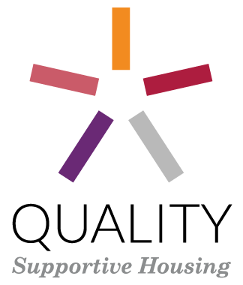

2014 Dimensions of Quality Institute Application
Sponsored with support from
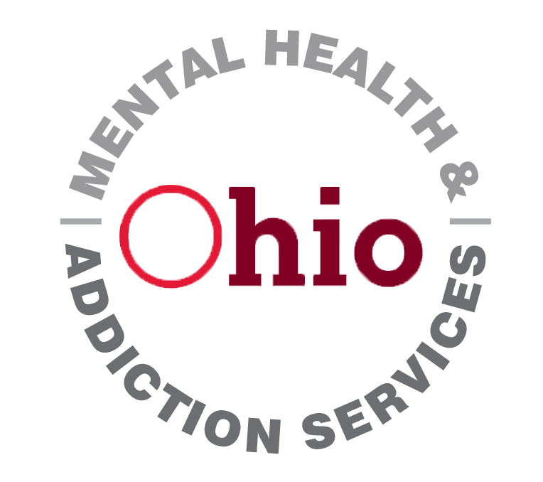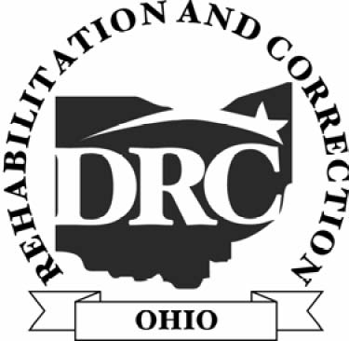


The Dimensions of Quality (Dimensions) Institute is a unique opportunity for housing and service providers at all levels of experience to hone their skills in operating supportive housing and providing services to individuals and families. It offers a chance for housing managers and providers of support services to draw on each other’s expertise and to learn from others in the industry as they create quality improvement plans for supportive housing projects in Ohio.
APPLICATION INSTRUCTIONS
The Institute’s goals are:
- Assure the quality of operations and tenant services on a day to day basis
- Build provider capacity to assess and improve performance on key quality indicators
- Strengthen practices to ensure the quality of supportive housing over time
- Assist providers in conducting self-assessments of their supportive housing and creating a framework for tracking improvement on key Dimensions over time
- Assist Ohio supportive housing providers to make the best use of their resources
- Provide Peer to Peer mentoring opportunities
- Create a continuing education, learning environment for supportive housing providers who have experienced staff turnover

The Institute is designed to be highly interactive and to provide detailed, individualized technical assistance to motivated teams with an existing portfolio of supportive housing. A tangible outcome of the Institute for teams will be a written quality improvement plan with baseline data that can be measured over time.

Participation in the Institute will be limited to 15 teams of 3 to 5 people per team. Team composition must include the property management and service provision sides of an existing PSH project. During the Institute, teams will focus on one of their projects (either single or scattered site).

To be eligible for the Institute, team applicants must be able to commit to attending all training sessions. It is critical to the success of each team that key senior management staff consistently participates in all sessions, and that the same team members attend each session. In addition, each team will be required to submit to CSH baseline data at the start of the Institute, commit to tracking the data over time and to report back to CSH one year from graduation on the agreed upon measurements. Team applications to the Institute will be reviewed by CSH with input from our funders before acceptance.

Schedule:
The training sessions will take place during three 2-day sessions in Columbus, Ohio.

Days 1 & 2
- May 13-14: Kickoff, Introduction, Project Design & Administration, Community

Days 3 & 4
- June 17-18: Supportive Services
Days 5 & 6
- July 15-16: Property and Housing Management

Deadline: To apply, submit one electronic copy of your application to CSH by April 7, 2014. Please answer all sections of the application and include the relevant attachments. CSH will evaluate all proposals and notify applicants of their selection by April 28, 2014.

Submission: Submit one copy to Ted Jones at ted.jones@csh.org. Please note, attachments are limited to 10 megabytes. If you are sending more than 10 megabytes in attachments you will need to send multiple emails. If you are unable to submit an application electronically, you may send a hard copy to:

Mailing Address:
Ted Jones
Senior Program Manager
CSH
P.O. Box 15955
Columbus OH 43215

Questions: Have questions regarding this application? Please contact Ted Jones at 614.228.6263 x225 or via email at ted.jones@csh.org.
Please provide contact information for each member of your team. Teams should consist of 2 to 3 senior management and staff involved in the operation of the supportive housing, and should include the supportive service provider, property manager and the asset manager (if applicable). Applicants should submit one application per team. The Dimensions of Quality Institute will not accept single applicants, only teams.
TEAM MEMBER INFORMATION

Designated Team Leader for the Institute
Name of Team Leader
Position
Organization Name
Address
Phone
Fax
Email
Role on team  (Circle all that apply) | Sponsor, Owner, Service Provider, Property Manager, Asset Manager, Other

Team Member #2
Name
Position
Organization Name
Address
Phone
Fax
Email
Role on team  (Circle all that apply) | Sponsor, Owner, Service Provider, Property Manager, Asset Manager, Other

Team Member #3
Name
Position
Organization Name
Address
Phone
Fax
Email
Role on team  (Circle all that apply) | Sponsor, Owner, Service Provider, Property Manager, Asset Manager, Other

Additional Team Members
If you are interested in having more than three (3) team members, please explain who else you would like to include on the team, including their name, agency, role on the team, and why you would like them to participate. (Note: Each additional team member above three (3) will require an additional fee to cover l costs for food and training materials)

Please answer the following questions. Expand the boxes as needed but please limit the total narrative to three pages.
APPLICATION NARRATIVE

- Institute Goals
Why does your team want to attend the Dimensions of Quality Institute? Describe what your project team hopes to gain from the Dimensions of Quality Institute and any other information you feel is relevant to evaluating your application. Please describe the supportive housing project you are currently operating and will bring to the Institute. Include number and type of units; population served, funding sources for capital, operations, and services; project partners. Describe any current issues you may be facing. Please include a description of any particular issues of quality that your team hopes to address during your participation in the Institute.

- Organizational Mission and Planning
Briefly describe the mission and strategic goals of each organization that will be represented on your team.

- Supportive Housing Experience
For each organization on your team, please detail the organization’s experience with managing property and/or providing services to your project’s target population. How many units of PSH does your team currently operate, manage or provide services to? Are these scattered or single site? In what counties are the units located? What populations does your team serve?

Agency Information
 | [Organization of Lead Team Member] | [Organization of Team Member 2] | [Organization of Team Member 3]
Year of Incorporation
Primary Population and Services Provided
Number of paid full-time staff members
Number of paid part-time staff members
Number of board members
Is your organization certified by OHMAS?
Is your organization accredited? If so, by whom?
Do you bill Medicaid for behavioral health services? For Medical services?
Do you operate our own projects or work with private landlords?

- Expectations of Participants
The Dimensions of Quality Institute is an intensive, hands-on training that will require a time commitment by senior staff. During the Institute, each team will create a comprehensive quality improvement plan, a customized outcomes measurement plan, and collect baseline data for their outcome measures. In order to accomplish these objectives, participants will be expected to:

- Attend all sessions
- Work during the sessions to complete Quality Improvement (QI) Action Plans and design an Outcomes Measurement Plan.
- Between sessions, complete homework as needed, in order to facilitate completion of QI Action Plans, Outcomes Measurement Plans and the gathering baseline data for the Outcomes Measurement Plans.
- Provide to CSH copies of a completed QI Action Plan (which will be held as confidential)
- Provide to CSH copies of completed Outcomes Measurement Plans, baseline data and follow-up outcomes data
- Upon acceptance into the Dimensions of Quality Institute, baseline will be measured and submitted to CSH.

CSH and the funders will be measuring the impact of this training on PSH quality. To measure the effectiveness of the Institute, teams will complete Pre-and Post-Institute Assessments. Also at the end of one year teams will submit relevant data to CSH as a measure against baseline data. CSH and the funders reserve the right to request additional data at year two to measure impact.

Please describe the ability of each team to commit staff time to the participation in the Institute, and to meet the expectations described above.

- Coordination with Continuum of Care
CoC Jurisdiction
Contact Person
Telephone Number
Email Address

- Dietary Restrictions and Other Accommodations Needed:
Please describe any dietary restrictions or other accommodations any team member will need to fully participate:
APPLICATION ATTACHMENTS

Please attach the following documents to your application:
- Two years of financial statements (audited if available)
- Copy of 501(c)3 tax exemption for applicable partners
- Resumes of each team member
Please note: If accepted into the Institute, organizations will be asked to provide the following:
- Registration check for $650 to cover the team’s participation in the Institute. This registration fee covers teams up to three members. Additional member’s fee is $35 per person per day.
- Board resolution from the project partners affirming commitment to participation in the Institute.

We understand and accept the expectations for the teams participating in the Dimensions of Quality Institute.

__________________________ _______________________________ __________________________
Signature Title Date

__________________________ _______________________________ __________________________
Signature Title Date

__________________________ _______________________________ __________________________
Signature Title Date

APRs or other approved existing report data

