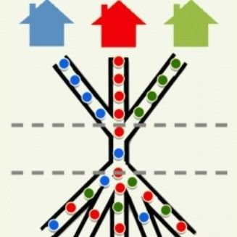

Are you 25 or Older

And Experiencing Homelessness?

If you do not have a safe and permanent place to stay, we would like to meet with you at any of the following
Access Points:

City Side | Agency | Location | Days/Hours
NORTH | Heartland Alliance Health (formerly Heartland Health Outreach) | 4750 N. Sheridan, Suite 200, 60640 | Mondays through Thursdays, 9am – 12pm
WEST | Heartland Alliance Health at Vital Bridges | 4121 W Lake St., 60624 | Wednesdays, 10am - 1pm (the first 15 people will be assessed)
 | Westside Health Authority | 5417 W. Division, 2nd Floor, 60651 | Mondays and Wednesdays, 1pm-3pm, ask for Danielle Dixon at the front desk
SOUTH | Matthew House | 3722 S. Indiana Ave, 60653 | Mondays through Fridays, 8am – 1pm
 | Featherfist | 2255 E. 75th St., 60649 | Mondays through Fridays, 1pm - 3pm

